Competitive Uniform Order Form: Girls 2023
 | Team: G20 Date: |  |  |  |  |  |  |  |  |  |  |  |  |  |  | 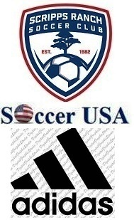
Manager Name:
E-mail:
Telephone:
Short Sizes: YS-YM-YL-XS-S-M-L-XL
Shirt Sizes: YS- YM-YL- XS- S-M -L-XL
T-Shirts Sizes: YS-YM-YL-XS - S-M-L-XL
 | Sock Sizes: XS-S- M-L
 | Number  1 to 18 | Player Name | Attended for sizing? |  | T-Shirt Size  Red & Navy | Shirt Size  Navy, for all |  |  |  | Shirt Size White, for new players |  |  |  | Short Size |  |  | Sock Size
 |  |  | Yes | No
1
2
3
4
5
6
7
8
9
10
11
12
13
14
15
16
17
18

Summary |  | YS | YM | YL | XS | S | M | L | XL | TOTAL
Total Jersey, White
Total Jersey, Navy
Total Shorts, Navy  (2 per player) |  | YS | YM | YL | XS | S | M | L | XL | TOTAL
T-Shirts  (2 per player) |  | YS | YM | YL | XS | S | M | L | XL | TOTAL
 | Red
 | Navy

Total Socks  (2 pairs per player) |  | XS | S |  | M | L | TOTAL
*Backpack: |  | *Duffel Bag:
*Only for new players
Please ensure you order the correct sizes, as orders cannot be modified once they are processed.
Please complete it in Microsoft Word format & send to: soccerusa@pacbell.net

G.K. Jersey, Sizes: (YS, YM, YL, S, M, L, and XL) Number:
Received by: Date:
Missing any items? YES NO If YES please explains:

